CST 320 – Assignment 3 part 1
Wilsonville, Fall 2020

Note: In this assignment, non-terminals are upper case and terminals are lower case.

- Given the grammar G =
A → bgB | dA | g
B → Ca | gA
C → aC | bdA | b

Determine and indicate which of the following strings are in the language defined by G and which are not. Construct parse trees for those that are in the language.

bgg out
ddbggg in
bgaba in
bggdg in
dad out
bgba in
abd out
dbga out

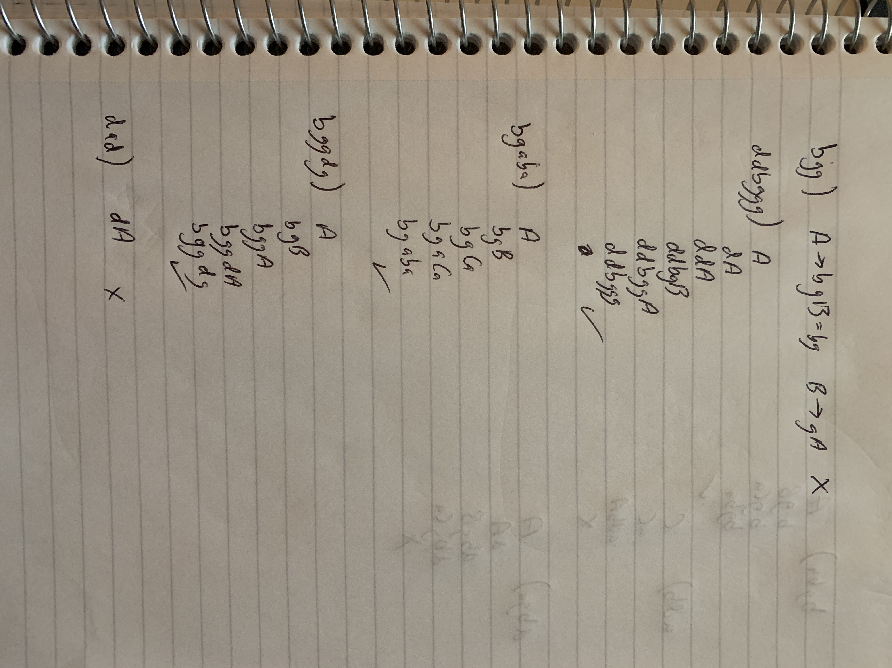
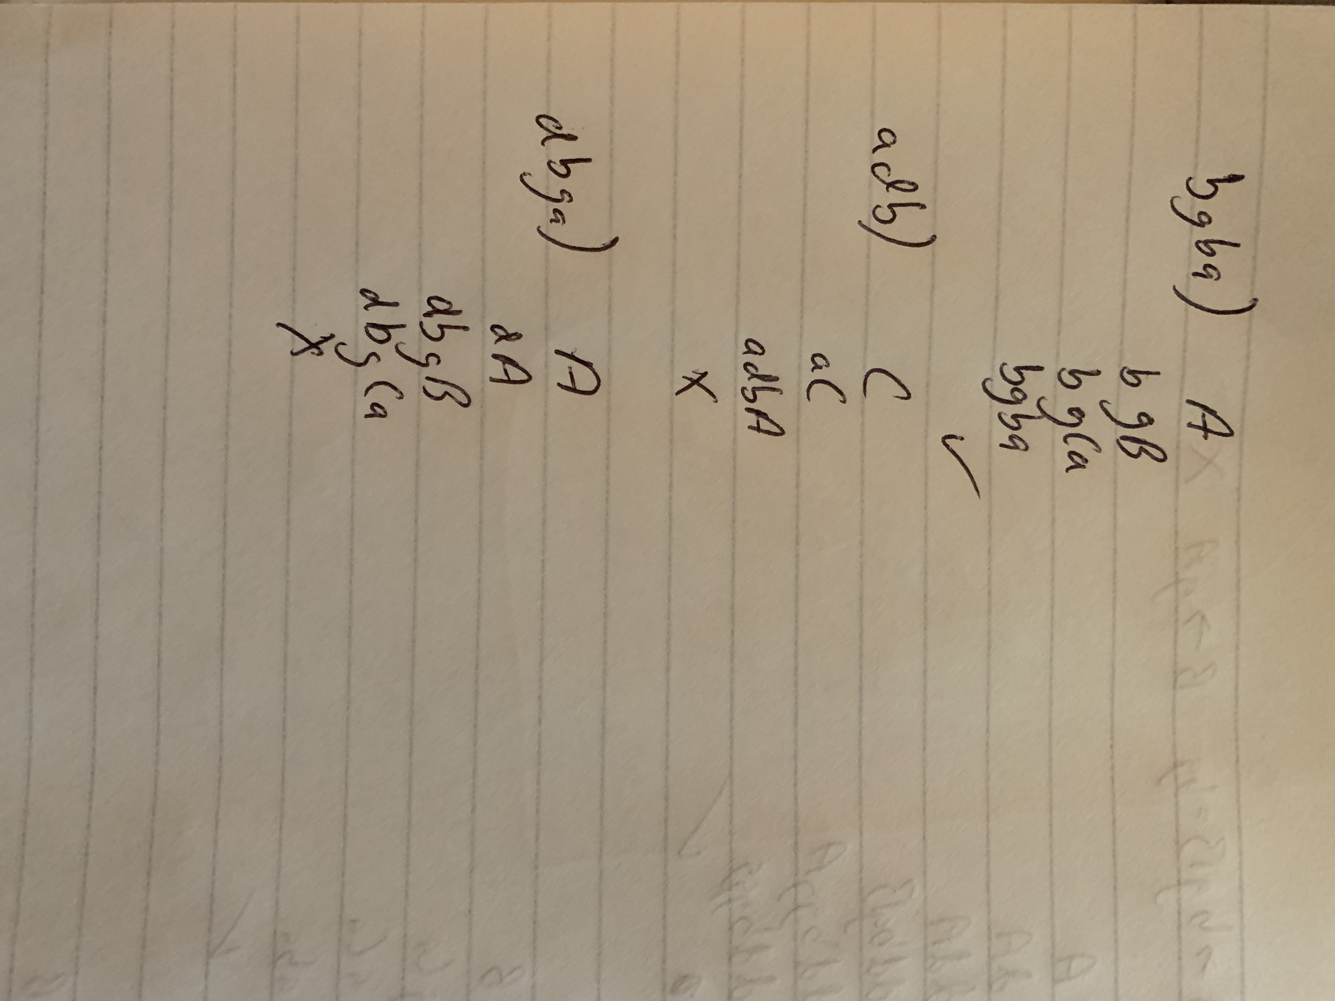

- Given the following grammar G =
S → aSbS | bSaS | λ

Show that G is ambiguous by constructing two different left-most derivations for the sentence “abab”.

S
aSbS
abS
abaSbS
ababS
abab

aSbS
abSaSbS
abaSbS
ababS
abab

- Using the following grammar
E → E + T | E – T | T
T → T * F | T / F | F
F → ( E ) | i

Construct parse trees and left-most derivations for the following expressions:

- i * (i + i)

E
T
T*F
F*F
i*F
i*(E)
i(E+T)
i*(T+T)
i*(F+T)
i*(i+T)
i*(i*F)
i*(i+i)

- i – i + i

E
E+T
E-T+T
T-T+T
F-T+T
i-T+T
i-F+T
i-i+T
i-i+F
i-i+i

